 |  | Organised by  Romanian National Committee  of the World Energy Council |  | 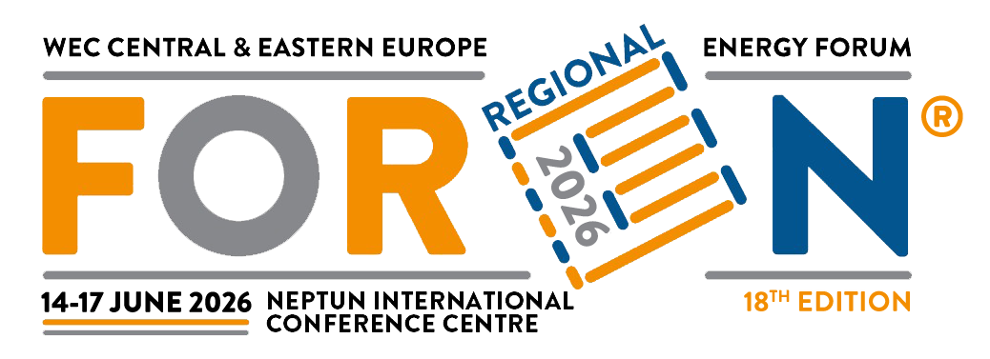
FOREN 2026 | WEC CENTRAL & EASTERN EUROPE REGIONAL ENERGY FORUM |  | SECURE, SUSTAINABLE AND AFFORDABLE ENERGY FOR CENTRAL AND EASTERN EUROPE

Accommodation registration form for FOREN 2026

Please complete the form and submit it by May 31, 2026 at the latest, to the following address of the event partner: WECO TRAVEL, Str Zambilelor, no. 96, Bucharest, sector 2, E-mail: foren2026@wecotravel.ro
Additional information can be obtained by phone: (+40 21) 242 23 23, +40 726 231 799,
contact person Ana Chiriac

Participant:

Name: .......................................................... Surename: .....................................................................................
Company: ......................................................... Position: ............................................................................
Company adress: .....................................................................................................................................................
Phone: ................................ Fax: ....................................E-mail: .....................................................................
Accompanying persons (as the case):

Name ........................................................... Surename .......................................................................................
Accommodation hotel - name: | HOTEL TERRA 4*
Rooms | SINGLE | DOUBLE | APARTMENT
Number of Rooms
Nights: | 12.06.2026 | 13.06.2026 | 14.06.2026
 | 15.06.2026 | 16.06.2026 | 17.06.2026
 | 18.06.2026
Optional: | Dinner:  Lunch: | Date: | Price: 110 lei/ pax/service

Accommodation hotel - name: | HOTEL AGORA 3*
Rooms | SINGLE | DOUBLE | APARTMENT
Number of Rooms
Nights: | 12.06.2026 | 13.06.2026 | 14.06.2026
 | 15.06.2026 | 16.06.2026 | 17.06.2026
 | 18.06.2026
Optional: | Dinner:  Lunch: | Date: | Price: 90 lei/ pax/service

Nume hotel/ Categoria | Price per room SGL regime (SGL room or DBL room) per night | Price per room DBL regime | Price per night  accommodation
TERRA 4* HOTEL
Standard Single | 295
Standard Double |  | 425
Apartment |  |  | 790
AGORA 3* HOTEL
Standard Single | 290
Standard Double |  | 350
Apartment |  |  | 460
Prices are in Lei RON, and includes: VAT and Breakfast.

Booking confirmation methods/ payments:
For booking confirmation with full sale depending on the number of nights chosen and hotel, payments are made directly to WECO TRAVEL by bank transfer/credit card/cash.

**The final payment confirmation should be send according with details bellow NO LATE than 31 MAY, 2026 at the latest**

For the deposit/payment made after 31 MAY, 2026, confirmation of reservations/rooms will be made depending on the availability of spaces.

- For payment by bank transfer : Transilvania Bank, IBAN RO21BTRL04101202124771XX, account holder: WECO TMC SRL, with mention “For FOREN 2026 accommodation, Hotel.........”. The confirmation of the payment will be send as soonest to foren2026@wecotravel.ro
2. Payment by card - accepted credit cards are: VISA, MASTERCARD.
3. After your confirmation regarding the payment by card, you will receive a secure payment link euplatesc.ro in which you will enter and process the data related to debiting the amount paid.

The rates are guaranteed in accordance with the reservation conditions.
For GDPR acceptance please access: https://www.wecotravel.ro/Ron/gdpr
Sales are non-refundable. No free cancellation.
Cancellation policy / penalties:
1. 50% penalty from the due ammount: for booking cancellation between 20 May 2026 si 04 June 2026
2. 100% penalty from the due ammount: for booking cancellation starting with 5 June 2026
3. 100% penalty – for now show
Calculation:
Arrival : Departure: Nr. of nights: Hotel : Depozit: Payment :

Date: ......................... Signature: ...............

